DEPARTMENT OF INFORMATION

TECHNOLOGY



WEB TECHNOLOGIES

[PCIT-107]

LABORATORY MANUAL

SUBMITTED BY: SUBMITTED TO:

DILPREET KAUR PF. HANIT KARWAL

URN:1905325

CRN:1921026

BRANCH-IT-A2

|  |  |  |
| --- | --- | --- |
| S.NO. | TOPIC | PAGE NO. |
| 1. | Create a simple web page by writing HTML and demonstrate the page headings, paragraphs, titles | 3-4 |
| 2. | Demonstrate the use of Links, Lists and Tables in HTML. | 5-8 |
| 3. | Create simple Forms in HTML and demonstrate the use of various form elements  like input box, text area, submit and radio buttons etc. | 9-11 |
| 4. | Demonstrate the use of cascading style sheets (CSS) (inline, internal and external) to  specify various aspects of style, such as colours and text fonts and sizes, in HTML  document. | 12-16 |
| 5. | Creation of Web pages using HTML5 and CSS3. | 17-21 |
| 6. | Demonstrate the use of Bootstrap Framework. | 22-24 |
| 7. | Creating web pages using PHP. | 25-28 |

**INDEX**

**PRACTICAL -1: Create a simple web page by writing HTML using a simple text editor, Notepad.**

**Demonstrate the following components of the web page:**

* **Page titles and Headings**
* **Paragraphs and Inline images**

**CODE:**

<!DOCTYPE html>

<html>

<head>

<title> First Practical

</title>

</head>

<body style="background-color:powderblue;">

<h1 style="color:black; text-align:center;"> Guru Nanak Dev Engineering College </h1>

<p style="color:black; text-align:left;"> Guru Nanak Dev Engineering College, one of the prestigious, oldest and minority institution of Northern India,was established under the aegis of Nankana Sahib Education Trust (NSET) in 1956. NSET was founded in memory of the most sacred temple of Nankana Sahib, birth place of Guru Nanak Dev Ji.The College was affiliated with Punjab University, Chandigarh since its inception. On establishment of Punjab Technical University, Jalandhar, since 1997 the college is affiliated with it, which is now known as I.K.Gujral Punjab Technical University (IKGPTU). The College courses are approved by All India Council for Technical Education, New Delhi. This is the first Engineering College of Punjab, which was conferred Autonomous Status by University Grants Commission (UGC), New Delhi in 2012 under section 2(f) and 12(B) of UGC Act 1956.Most of the undergraduate courses are accredited by National Board of Accreditation about 3 times since 2004. The college is accredited with ‘A” Grade by NAAC, UGC. Tata Consultancy Services (TCS) has accredited this college twice for placement purpose. The college is also ISO 9001-2015 Certified. </p>

<img src="sym.png" alt="Symbol" width="350" height="333">

</body>

</html>

**OUTPUT:**

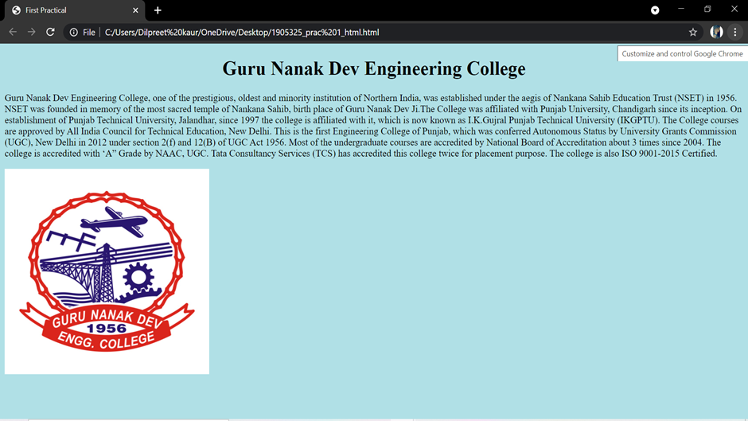

**PRACTICAL-2: Demonstrate the use of Links, Lists and Tables in HTML.**

**CODE:**

<!DOCTYPE html>

<head>

<title> Second Practical</title>

<style>

table,th,td

{border:2px solid black;padding:10px ;}

</style>

</head>

<body>

<h1 style="color:blue;">Department of Information Technology</h1>

<p>This Department was established in 2001. The mission of the Department of Information Technology is to impart high quality post graduate and under-graduate education and carry out leading-edge research in the discipline of Information Technology.The department currently runs academic program leading to the award of B.Tech. in Information Technology degree of Punjab Technical University Jalandhar. The Department has various laboratories equipped with state-of-the-art computing facilities to support the research and teaching activities. A library with a lot of books on Information Technology for the exclusive use of the faculty and students is located in the premises of the Department.At present Dr. Kiran Jyoti is Head of the Department. </p>

<h3>Click on the below link</h3>

<a href="https://it.gndec.ac.in">Visit IT Department!!</a>

<h1 style="color:blue;">Students studying in GNDEC</h1>

<table style="width:10%">

<tr>

<th>S.No.</th>

<th>Name</th>

<th>Branch</th>

</tr>

<tr>

<td>1</td>

<td>Daman</td>

<td>IT</td>

</tr>

<tr>

<td>2</td>

<td>Riya</td>

<td>CSE</td>

</tr>

<tr>

<td>3</td>

<td>Sam</td>

<td>IT</td>

</tr>

</table>

<h2 style="color:black;">Unordered list</h2>

<ul>

<li>IT</li>

<li>CSE</li>

<li>Mechanical</li>

<li>Production</li>

<li>Civil</li>

</ul>

<h2 style="color:black;">Ordered list</h2>

<ol>

<li>IT</li>

<li>CSE</li>

<li>Mechanical</li>

<li>Production</li>

<li>Civil</li>

</ol>

</body>

</html>

**OUTPUT:**

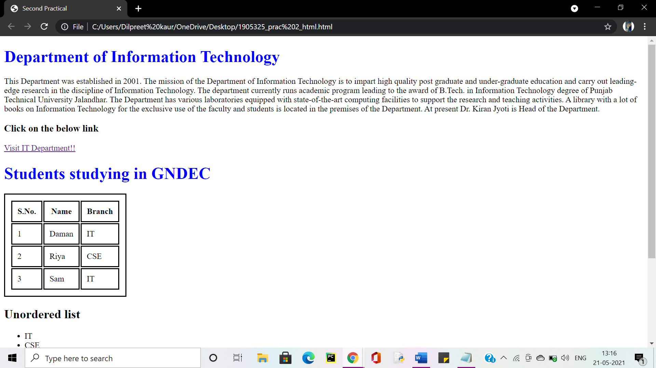

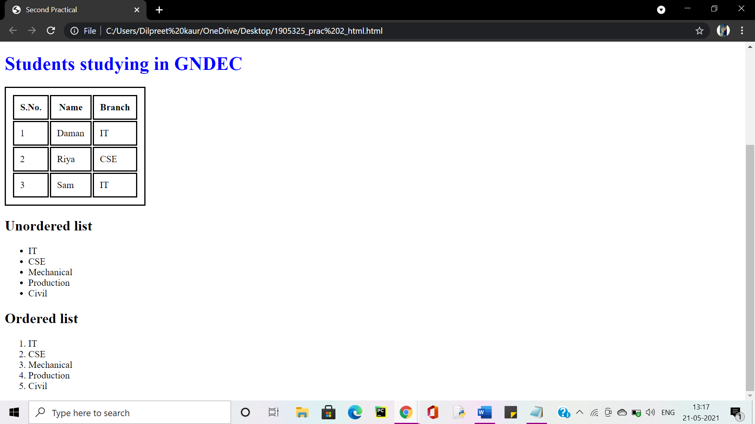

**PRACTICAL-3: Create simple Forms in HTML and demonstrate the use of various form elementslike input box, text area, submit and radio buttons etc.**

**CODE:**

<!DOCTYPE html>

<html>

<body>

<h1>STUDENT INFORMATION </h1>

<form>

<label for="fname">First name:</label><br>

<input type="text" id="fname" name="fname"><br><br>

<label for="lname">Last name:</label><br>

<input type="text" id="lname" name="lname" ><br><br>

<label for="Gender">Gender:</label><br>

<input type="radio" id="male" name="Gender" value="male">

<label for="male">Male</label><br>

<input type="radio" id="female" name="Gender" value="female">

<label for="female">Female</label><br>

<input type="radio" id="other" name="Gender" value="other">

<label for="other">Other</label><br><br>

<label for="DOB">DOB:</label><br>

<input type="date" id="DOB" name="DOB"><br><br>

<label for="URN">University Rollno:</label><br>

<input type="number" id="URN" name="URN"><br><br>

<label for="Email">Email ID:</label><br>

<input type="varchar" id="Email" name="Email"><br><br>

<label for="Contact">Contact No:</label><br>

<input type="number" id="Contact" name="Contact"><br><br>

<label for="State">State:</label><br>

<select id="State" name="State">

<option value="Punjab">Punjab</option>

<option value="Haryana">Harayana</option>

<option value="Bihar">Bihar</option>

<option value="Delhi">Delhi</option>

<option value="Uttar pardesh">Uttar pardesh</option>

<option value="Jammu & Kashmir">Jammu & Kashmir</option>

<option value="Other">Other</option>

</select><br><br>

<label for="Views">Views about GNDEC:</label><br>

<textarea name="message" rows="5" cols="20"></textarea>

<br><br>

<input type="submit" value="Submit">

<input type="reset">

</form>

</body>

</html>

**OUTPUT:**

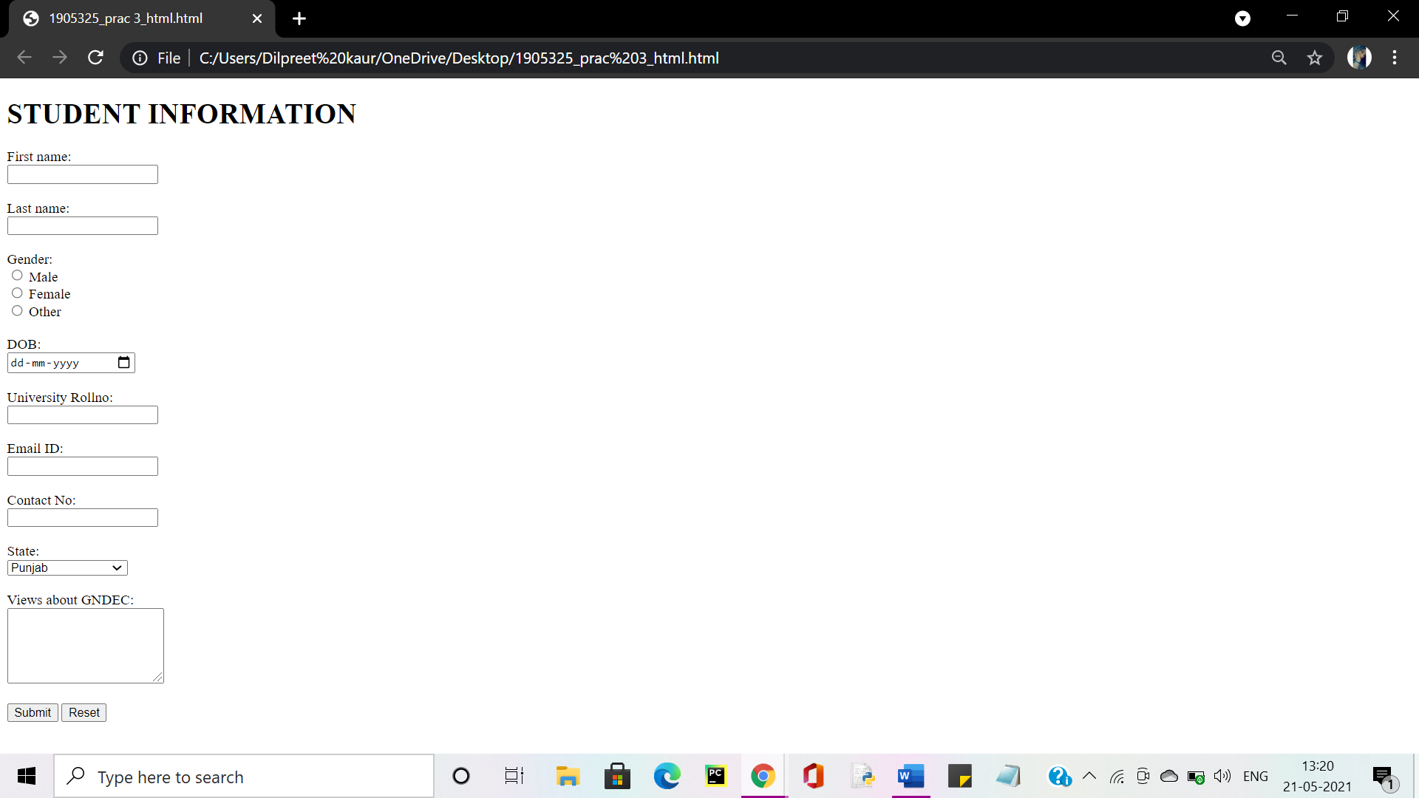

**PRACTICAL-4: Demonstrate the use of cascading style sheets (CSS) (inline, internal and external) tospecify various aspects of style, such as colours and text fonts and sizes, in HTML document.**

**CODE 1: INTERNAL AND INLINE**

html>

<head>

<style>

body {

background-color:violet;

}

h1 {

background-color:lightblue;

color: DarkGreen;

text-align: center;

text-transform: uppercase;

text-shadow: 2px 2px 5px yellow;

font-family: "Times New Roman";

}

p {

background-color:yellow;

color: navy;

font-family: "Arial";

margin: 25px 50px;

border: 1px solid black;

}

</style>

</head>

<body>

<h1>Internal css</h1>

<p>The internal style sheet is used to add a unique style for a single document.It is defined in <head> section of the HTML page inside the style tag.Internal styles apply to whole pages but not to multiple HTML documents.Several pages can be styled by repeating the same block of internal styles in them.Include CSS in HTML so it would be convenient to change and update content. Internal stylesheets can make website maintenance more challenging.</p>

<h1 style="background-color:lightblue;color:SlateBlue;text-align:center;text-shadow: 2px 2px 5px Gray;

font-family: "Times New Roman";">inline css</h1>

<p style=" background-color:orange;color: navy;font-family: "Arial";margin: 25px 50px;border: 1px solid black;">Inline styles look and operate much like CSS, with a few differences.Inline styles directly affect the tag they are written in, without the use of selectors.You can have as many property value pairs as you want.Unlike normal CSS syntax, inline styling does not use selectors or curly braces. Don’t forget to include the semicolon ; after each pair!</p>

</body>

</html>

**OUTPUT:**

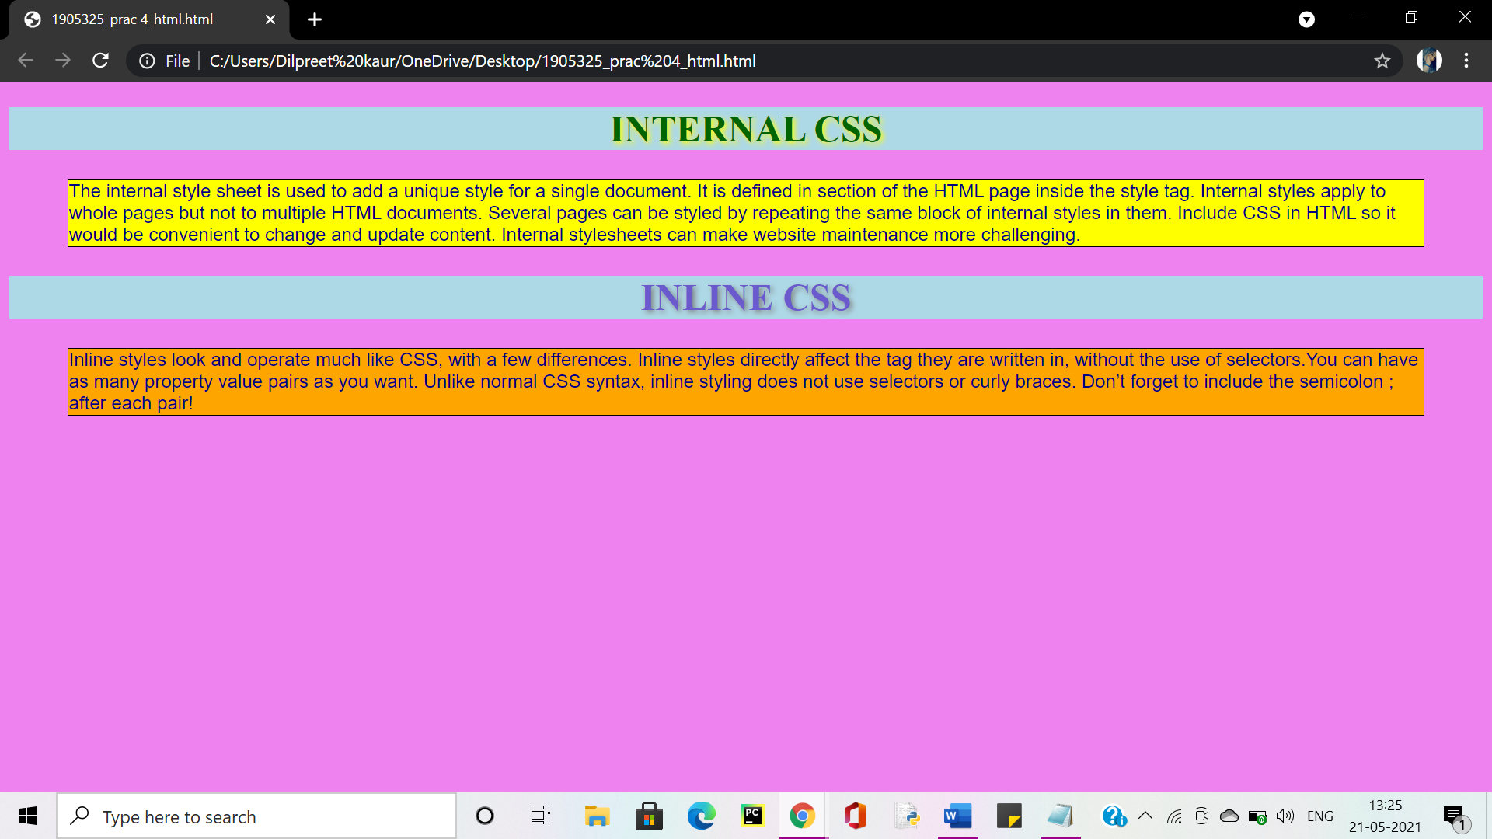

**CODE 2: EXTERNAL**

<!DOCTYPE html>

<html>

<head>

<link rel="stylesheet" href="external.css">

</head>

<body>

<h1>External css</h1>

<p>With an external style sheet, you can change the look of an entire website by changing just one file!Each HTML page must include a reference to the external style sheet file inside the <link> element, inside the head section.An external style sheet can be written in any text editor, and must be saved with a .css extension.The external .css file should not contain any HTML tags.</p>

</body>

</html>

**THE EXTERNAL FILE (external.css) LOOKS LIKE:**

body {

background-color:violet;

}

h1{

background-color:lightblue;

color: Brown;

text-align: center;

text-transform: uppercase;

text-shadow: 2px 2px 5px yellow;

font-family: "Times New Roman";

}

p {

background-color:Cornsilk;

color: navy;

font-family: "Arial";

margin: 25px 50px;

border: 1px solid black;

}

**OUTPUT:**

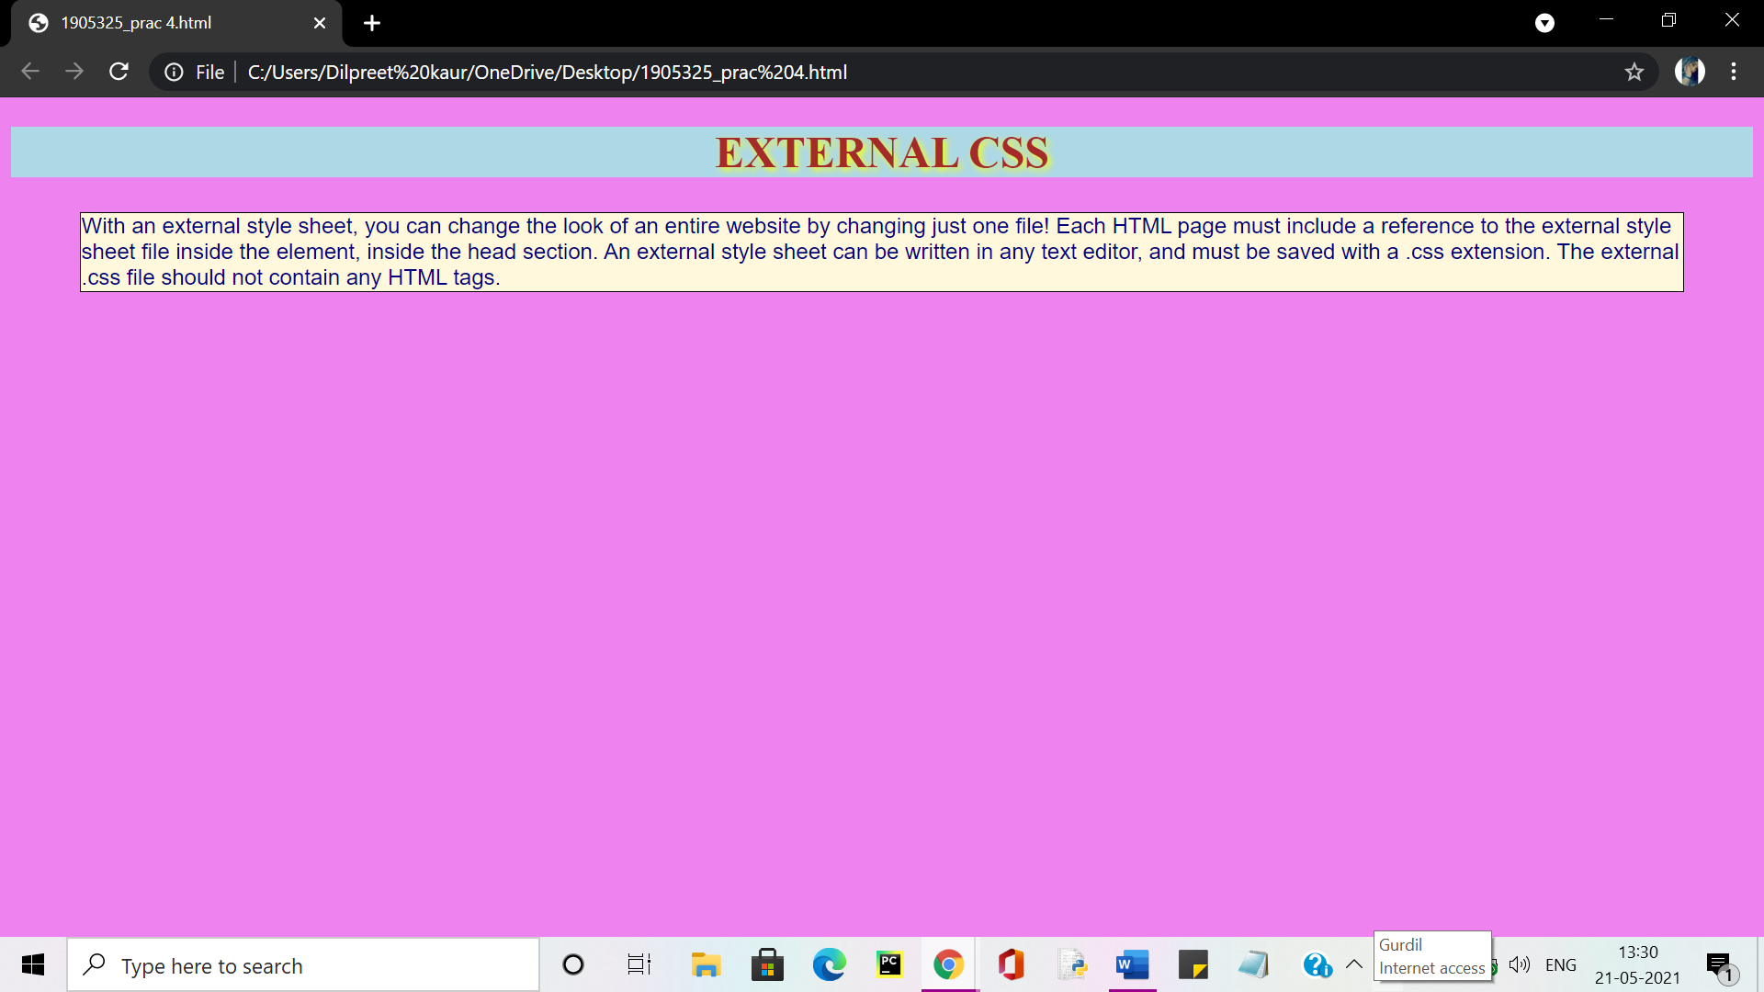

**PRACTICAL-5: Creation of Web pages using HTML5 and CSS3.**

**CODE:**

<!DOCTYPE html>

<html>

<head>

<title>DILPREET CREATIONS</title>

<<link rel="stylesheet" href="style.css">

</head>

<body>

<header>

<div class="main">

<ul>

<li class="active"><a href="#">Home</a></li>

<li><a href="#">Courses</a></li>

<li><a href="#">Gallery</a></li>

<li><a href="#">About</a></li>

<li><a href="#">Contact</a></li>

</ul>

</div>

<div class="title">

<h1>GNDEC LDH.</h1>

</div>

<div class="button">

<a href="#" class="btn"> Watch Video </a>

<a href="#" class="btn"> Learn More </a>

</div>

</header>

<footer id="main-footer">

<p>Copyright 2021 &copy; Dilpreet Kaur 1921026/1905325</p>

</footer>

</body>

</html>

**THE FILE (style.css) LOOKS LIKE:**

*{

margin: 0;

padding: 0;

font-family: Century Gothic;

}

header{

background-image:linear-gradient(rgba(0,0,0,0.5),rgba(0,0,0,0.5)), url(2.jpeg);

height: 100vh;

background-size: cover;

background-position: centre;

}

ul{

float: right;

list-style-type: none;

margin-top: 25px;

}

ul li{

display: inline-block;

}

ul li a{

text-decoration: none;

color: #fff;

padding: 5px 20px;

border: 1px solid transparent;

transition: 0.06s ease;

}

ul li a:hover{

background-color: #fff;

color: #000;

}

ul li.active a{

background-color: #fff;

color: #000;

}

.main{

max-width: 1200px;

margin: auto;

}

.title{

position: absolute;

top: 50%;

left: 50%;

transform: translate(-50%,-50%);

}

.title h1{

color: #fff;

font-size: 70px;

}

.button{

position: absolute;

top: 62%;

left: 50%;

transform: translate(-50%,-50%);

}

.btn{

border: 1px solid #fff;

padding: 10px 30px;

color: #fff;

text-decoration: none;

transition: 0.6s ease;

}

.btn:hover{

background-color: #fff;

color: #000;

}

**OUTPUT:**

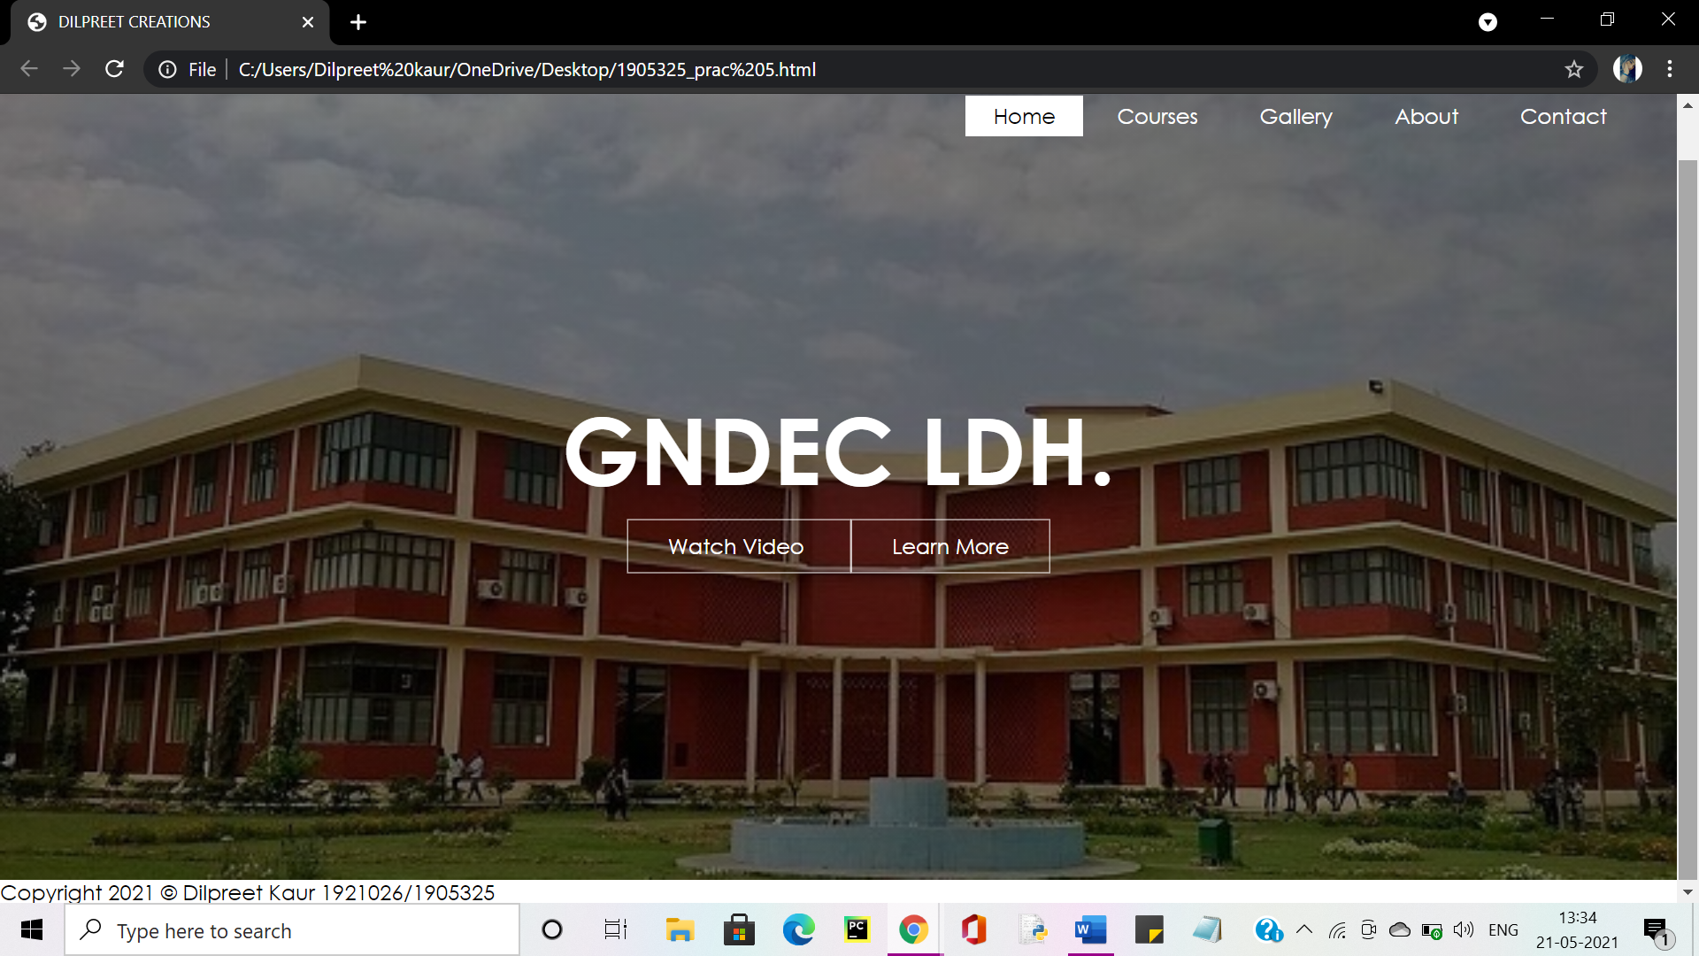

**PRACTICAL-6: Demonstrate the use of Bootstrap Framework.**

**CODE:**

<!DOCTYPE html>

<html lang="en">

<head>

<title>Bootstrap Example</title>

<meta charset="utf-8">

<meta name="viewport" content="width=device-width, initial-scale=1">

<link rel="stylesheet" href=styles.css">

<script src="https://ajax.googleapis.com/ajax/libs/jquery/3.1.1/jquery.min.js"></script>

<script src="https://maxcdn.bootstrapcdn.com/bootstrap/3.3.7/js/bootstrap.min.js"></script>

</head>

<body>

<form action="" method="post">

<form class="form-signin">

<div class="container-fluid">

<div class="row">

<h2 class="form-signin-heading">Please sign in</h2>

<div class="col-sm-4" style="&nbsp"></div>

<div class="col-sm-4"><input type="text" id="u1" placeholder="Username"

required class="form-control"/></div>

<div class="col-sm-4" style="&nbsp"></div>

</div>

<div class="row">

<div class="col-sm-4" style="&nbsp"></div>

<div class="col-sm-4"><input type="password" id="p1" placeholder="Password"

required class="form-control"/></div>

<div class="col-sm-4" style="&nbsp"></div>

<button class="btn btn-lg btn-primary" type="submit">Sign in</button>

</div>

</form>

</body>

<script src="https://ajax.googleapis.com/ajax/libs/jquery/3.1.1/jquery.min.js"></script>

<script>

$(document).ready(function(){

$("#s1").click(function(){

var u1=$("#u1").val();

var p1=$("#p1").val();

if($("u1").val()==null||$("p1").val()==null)

alert("please fill out this field");

else if( $theForm.valid() ) {

$theForm.submit();

}

});

});

</script>

</html>

**OUTPUT:**

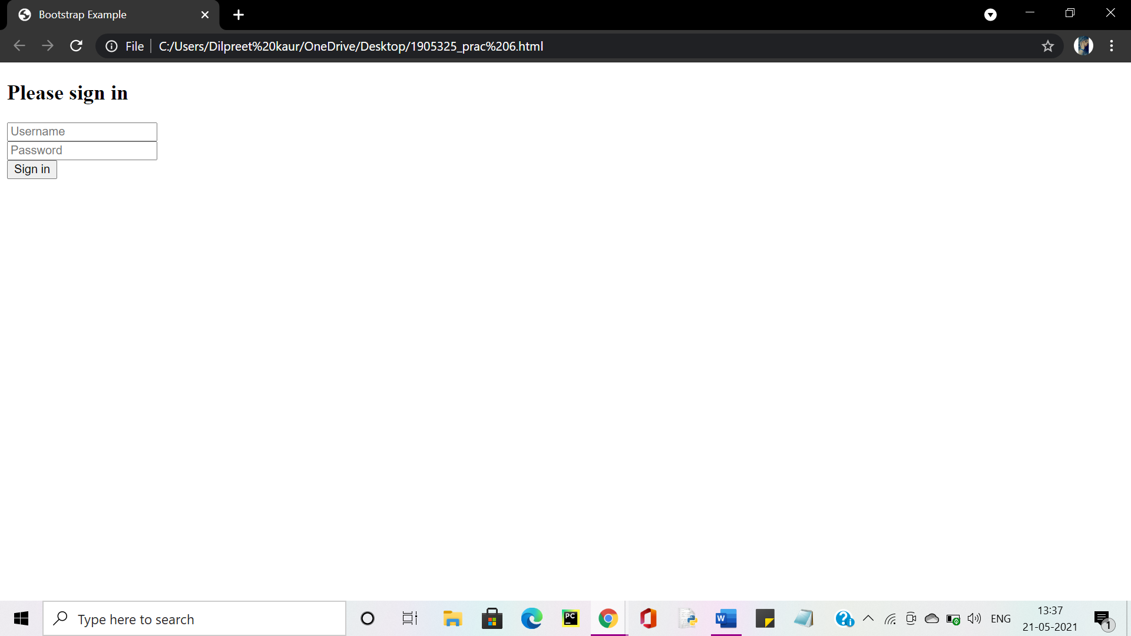

**PRACTICAL-7: Creating web pages using PHP.**

**CODE:**

<!doctype html>

<html lang="en">

<head>

<meta charset="utf-8">

<meta name="viewport" content="width=device-width, initial-scale=1">

<link href="https://cdn.jsdelivr.net/npm/bootstrap@5.0.0-beta3/dist/css/bootstrap.min.css" rel="stylesheet"

integrity="sha384-eOJMYsd53ii+scO/bJGFsiCZc+5NDVN2yr8+0RDqr0Ql0h+rP48ckxlpbzKgwra6" crossorigin="anonymous">

<title>PRACTICAL 7</title>

<body style="background-color:#FFEFD5;">

<style>

.topnav {

overflow: hidden;

background-color:#ffA07a;

}

.topnav a {

float: left;

color: #800000;

text-align: center;

padding: 14px 16px;

text-decoration: none;

font-size: 20px;

}

.topnav a:hover {

background-color:#787878;

color: rgb(255, 255, 255);

}

.topnav a.active {

background-color:#787878 ;

color: rgb(0, 0, 0);

}

</style>

</head>

<div class="topnav" style="border-radius: 5px;">

<a class="active" href="#HOME">HOME</a>

<a href="# Your Orders">Your Orders</a>

<a href="#Contact">Contact</a>

<a href="#About Us">About Us</a>

</div>

<br>

<div class="container" >

<div id="carouselExampleSlidesOnly" class="carousel slide" data-bs-ride="carousel">

<div class="carousel-inner">

<div class="carousel-item active">

<center><img src="f.png " width="1000" height="450" ></center>

<br> <div>

<center><h2><p style="color: rgb(0, 0, 0)";>""Food brings people together on many different levels.Its nourishment for the soul and body.Its truly love...""</h2></p>

<br><div>

<h3 style="color:blue;","font-family:verdana;"> Add a joy of best Taste!<h3></center>

</div>

</div>

</div>

</div>

</div>

</div><br>

<div class="card" style="width: 125rem; background: linear-gradient(rgb(107, 192, 231),rgb(220, 211, 235))" >

<div class="card-body" alignment="center">

<h5 class="card-title">Get the best food at your doorsteps... </h5>

<a href="#" class="btn btn-primary">ORDER NOW</a>

</div>

</div>

</body>

</html

**OUTPUT:**

